

**Running Shoes UI/UX Project Report**

**Student Name:** Daniel Giedraitis

**Student Number:** C00260331

**Lecturer:** Phil Morris

**Date:** 29/04/2024

**Table of Contents**

**1. Introduction** 2

**2. User Interface Design** 3

**2.1. Chose a specific website** 3

**2.2. Researched the Target Audience** 4

**2.3. Personas** 5

**Persona 1: Sarah Johnson** 5

**Persona 2: Michael Rodriguz** 6

**Persona 3: Emily Clark (Additional Needs)** 7

**Persona 4: Alex Patel (Additional Needs)** 8

**2.4. Journey Maps** 9

**User journey map 1: Sarah Johnson** 9

**User journey map 2: Michael Rodriguz** 10

**2.5. Paper prototype** 11

**2.6. Wireframes** 12

**Wireframe 1: Home Page** 12

**Wireframe 2: Shop Page** 13

**Wireframe 3: Product Page** 14

**Wireframe 4: Cart Page** 15

**Wireframe 5: Checkout Page** 16

**2.7. Considered the UI Principles** 17

**3. User Experience Evaluation** 18

**3.1. Implemented UI Design** 18

**Page 1: Home Page** 18

**Page 2: Shop Page** 19

**Page 3: Product Page** 20

**Page 4: Cart Page** 21

**Page 5: Checkout Page** 22

**3.2. Conducted Usability Testing** 23

**4. Conclusion** 25

# **1. Introduction**

In the world of e-commerce, the user interface (UI) design plays an important role in shaping the overall user experience and influencing purchasing decisions. This project focuses on the design and evaluation of a UI for a website specializing in the sale of running shoes for individuals of all ages and genders. By delving into the intricacies of UI/UX design principles and methodologies, the aim is to create a seamless and enjoyable shopping experience tailored to the needs and preferences of the target audience.

The project begins with thorough research into the target audience, aiming to gain deep insights into their demographics, behaviors, and motivations when it comes to purchasing running shoes online. With this knowledge, the UI design process unfolds, incorporating fundamental principles such as visual hierarchy, consistency, and accessibility to create an intuitive and visually appealing interface. Usability testing and feedback collection provide valuable insights into the effectiveness of the UI design, guiding iterative refinements to enhance usability and user satisfaction.

Through the creation of personas, journey maps, wireframes, and prototypes, the project aims to thoroughly address the needs and preferences of diverse user segments, including those with special needs. By prioritizing inclusivity and user-centered design principles, the goal is to deliver a UI that supports a positive and engaging shopping experience for all users, regardless of their background or abilities.

# **2. User Interface Design**

## **2.1. Chose a specific website**

For this assignment, the focus is on designing the user interface (UI) for a website dedicated to selling running shoes tailored for men, women, and kids. The primary objective of this website is to offer users a seamless and enjoyable shopping experience, allowing them to find and purchase high-quality running shoes conveniently online.

With the increasing trend of online shopping, particularly for specialized items like athletic footwear, it's essential to create a website that specifically matches the needs and preferences of running enthusiasts. By specializing in running shoes and catering to different age groups and genders, this website aims to become a go-to destination for individuals looking for the perfect pair of shoes to support their active lifestyle.

The UI design will play an important role in shaping users' interactions with the website, influencing their overall experience and satisfaction. Through thoughtful design choices and strategic implementation of UI principles, such as visual hierarchy, consistency, and clarity, the goal is to create an intuitive and visually appealing interface that appeals with the target audience.

In summary, the chosen website for this assignment presents an exciting opportunity to delve into the complicated world of UI design within the context of e-commerce, particularly focusing on the unique requirements of selling running shoes online. Through comprehensive research and strategic design decisions, the aim is to deliver a user-centric website that exceeds expectations and supports a positive shopping experience for all users.

## **2.2. Researched the Target Audience**

To create a user interface (UI) design that resonates with the target audience and fulfills their needs effectively, extensive research was conducted to gain deep insights into the demographics, preferences, and online shopping behaviors of individuals interested in purchasing running shoes.

The research process began with the identification of key demographic segments within the target audience, including age groups, gender distribution, and geographic locations. Understanding these demographic factors provided a foundational understanding of the user base and allowed for more tailored design decisions.

Also, qualitative research methods such as surveys and interviews were employed to delve deeper into the motivations, preferences, and pain points of potential users. Surveys were distributed to fellow students, friends, and family with an interest in running or athletic footwear, collecting quantitative data on their purchasing habits, brand preferences, and expectations from an online running shoe store. Additionally, in-depth interviews were conducted with select participants to gather qualitative insights into their shopping experiences, challenges encountered, and desired features in an online running shoe store.

One of the key findings from the research was the importance of convenience and accessibility in online shopping experience. Many people expressed a preference for websites with intuitive navigation, quick search functionality, and easy checkout processes. Additionally, factors such as product variety, price transparency, and customer reviews emerged as significant influencers in the purchasing decision-making process.

Overall, the research revealed notable differences in preferences and priorities among different demographic segments. For example, younger users tended to prioritize trendy designs and brand reputation, while older users highlighted factors like comfort, durability, and value for money.

## **2.3. Personas**

To create a user-centered design, four distinct personas were developed, each representing a unique segment of the target audience interested in purchasing running shoes. These personas consisted of a variety of demographics, motivations, and challenges, providing valuable insights to the UI design process.

### **Persona 1: Sarah Johnson**

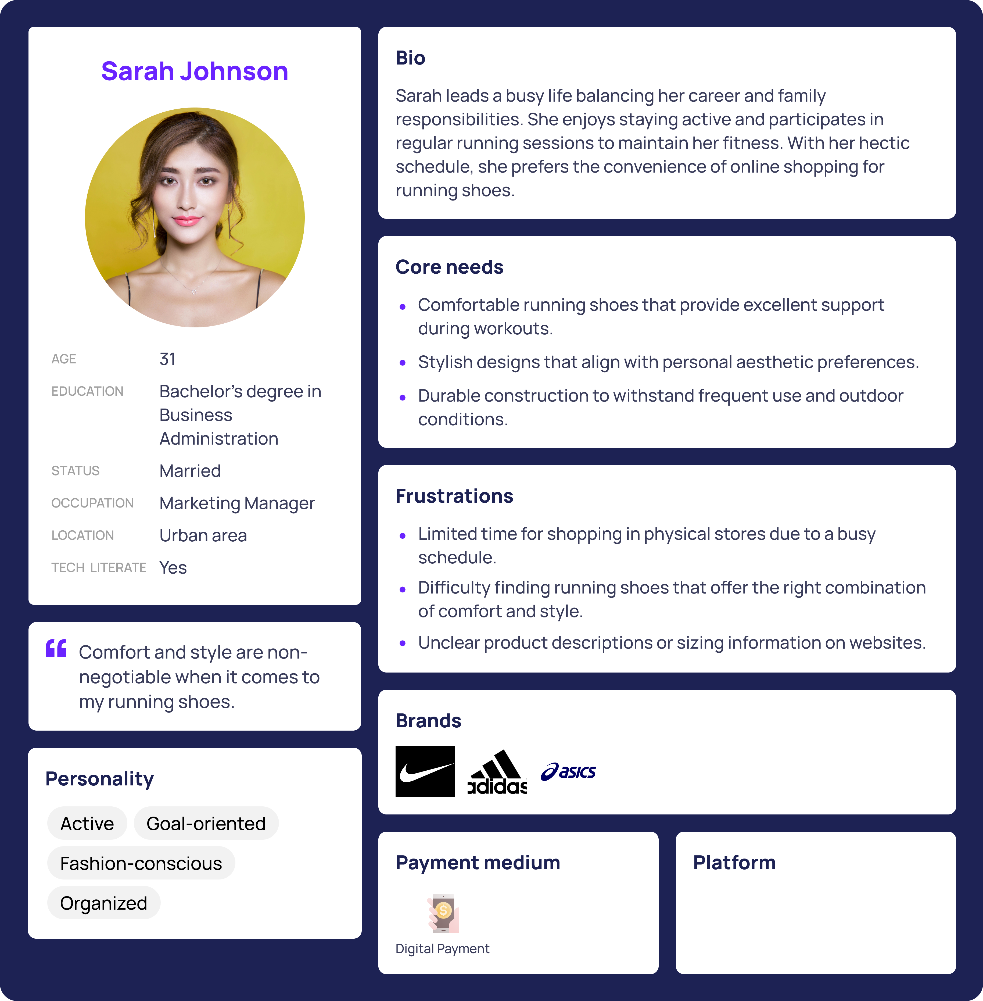

### **Persona 2: Michael Rodriguz**



### **Persona 3: Emily Clark (Additional Needs)**



### **Persona 4: Alex Patel (Additional Needs)**

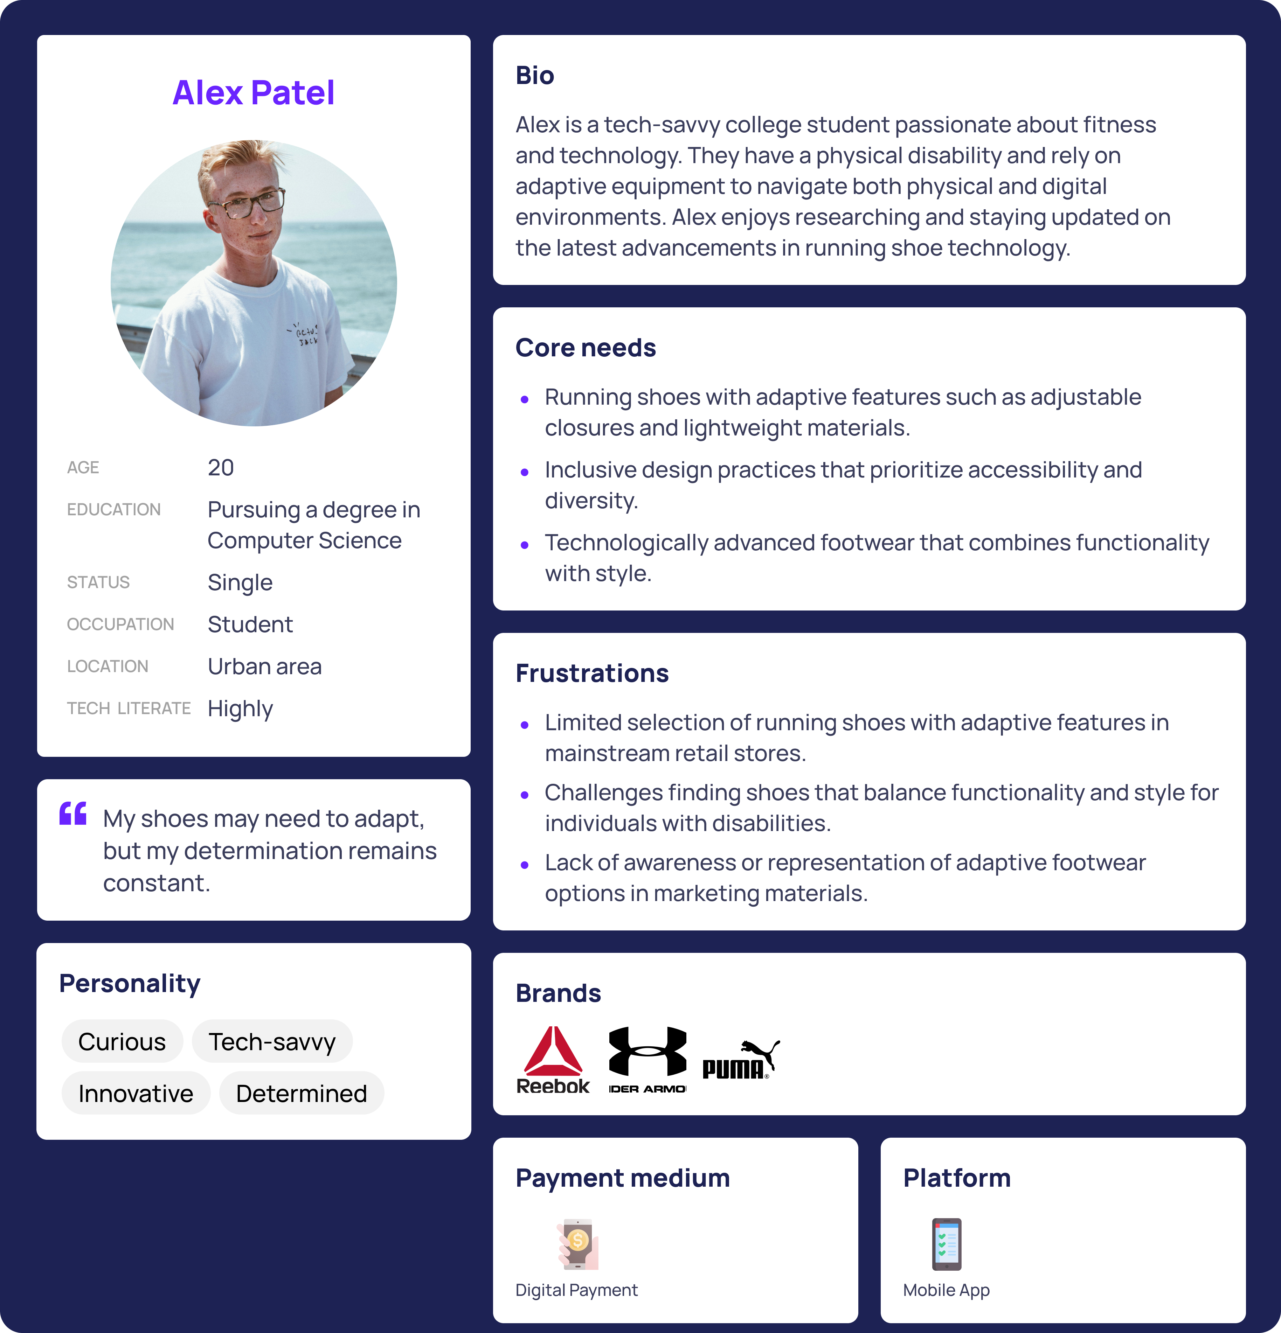

## **2.4. Journey Maps**

These journey maps visualize the user experience for two key personas navigating the website to purchase running shoes. By highlighting key touchpoints, emotions, and pain points throughout the user journey, these journey maps offer valuable insights into the user experience and opportunities for improvement.

### **User journey map 1: Sarah Johnson**

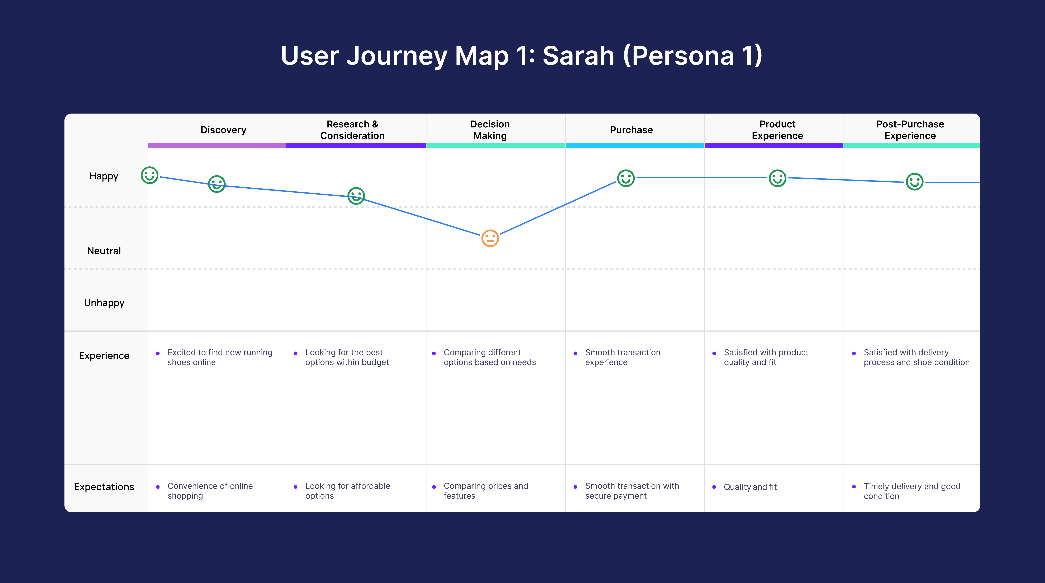

### **User journey map 2: Michael Rodriguz**

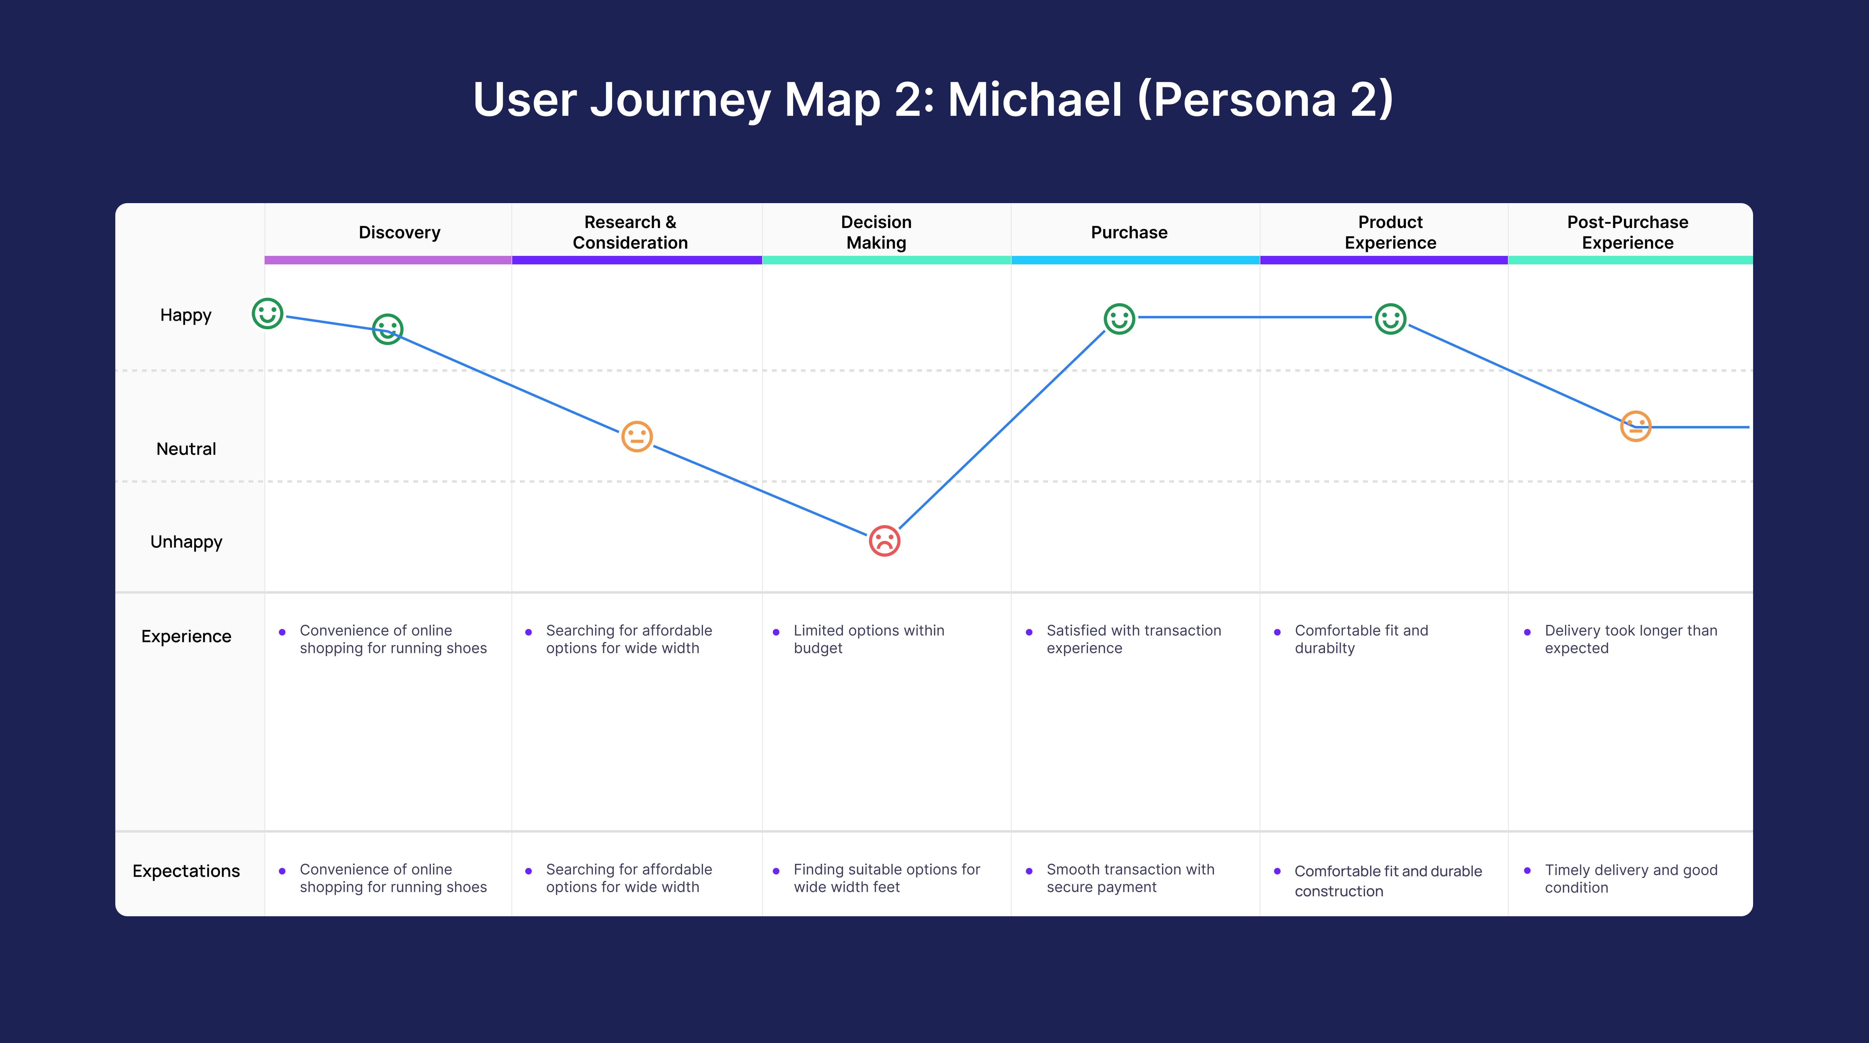

## **2.5. Paper prototype**

The paper prototype serves as an early-stage design iteration, allowing for the gathering of feedback and testing of design decisions before digital implementation. Through testing and iteration, insights gained from the paper prototype will be used to refine the UI design, ensuring a user-friendly experience for website visitors.

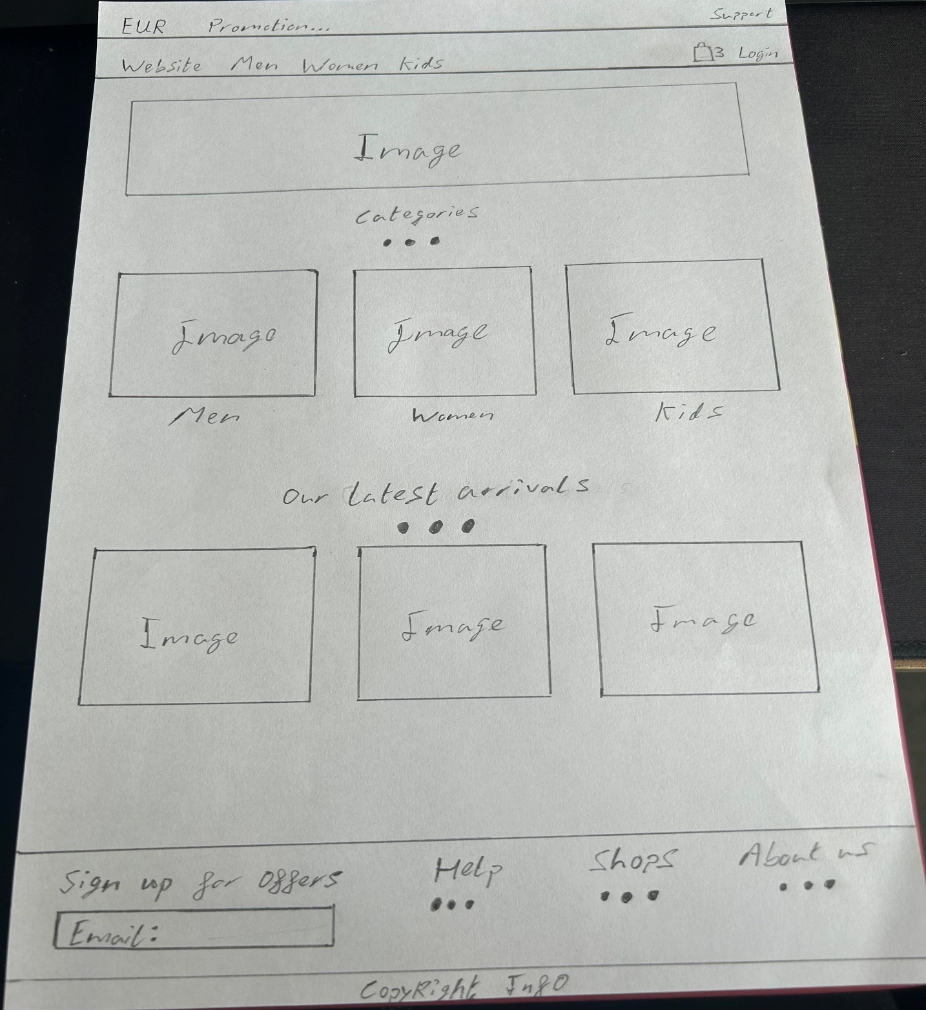

## **2.6. Wireframes**

Wireframes and mock-ups were created using Figma, serving as blueprints for the UI design of the running shoe website. These wireframes provide a visual representation of key pages such as the home page, shop page, product page, cart page, and checkout process, guiding the design process and ensuring alignment with user needs and preferences.

### **Wireframe 1: Home Page**

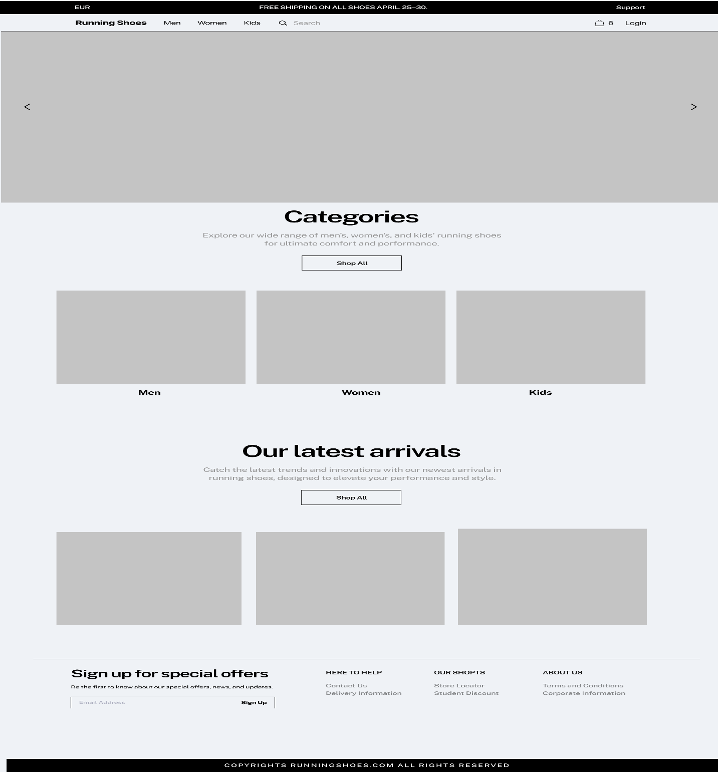

### **Wireframe 2: Shop Page**

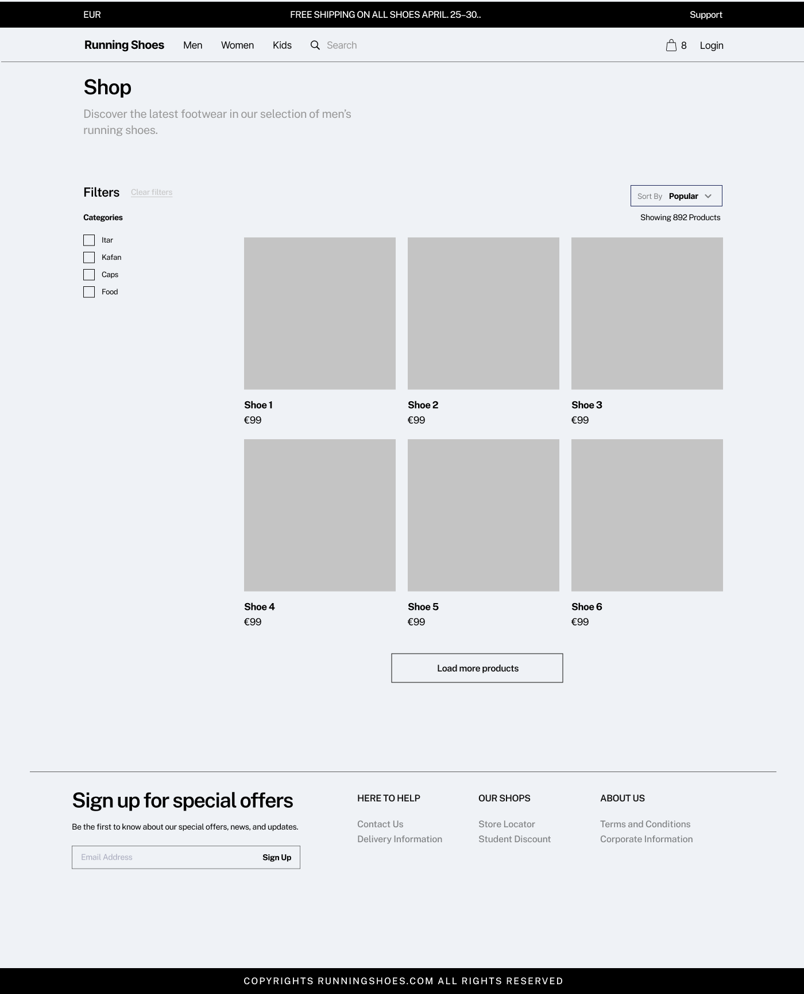

### **Wireframe 3: Product Page**

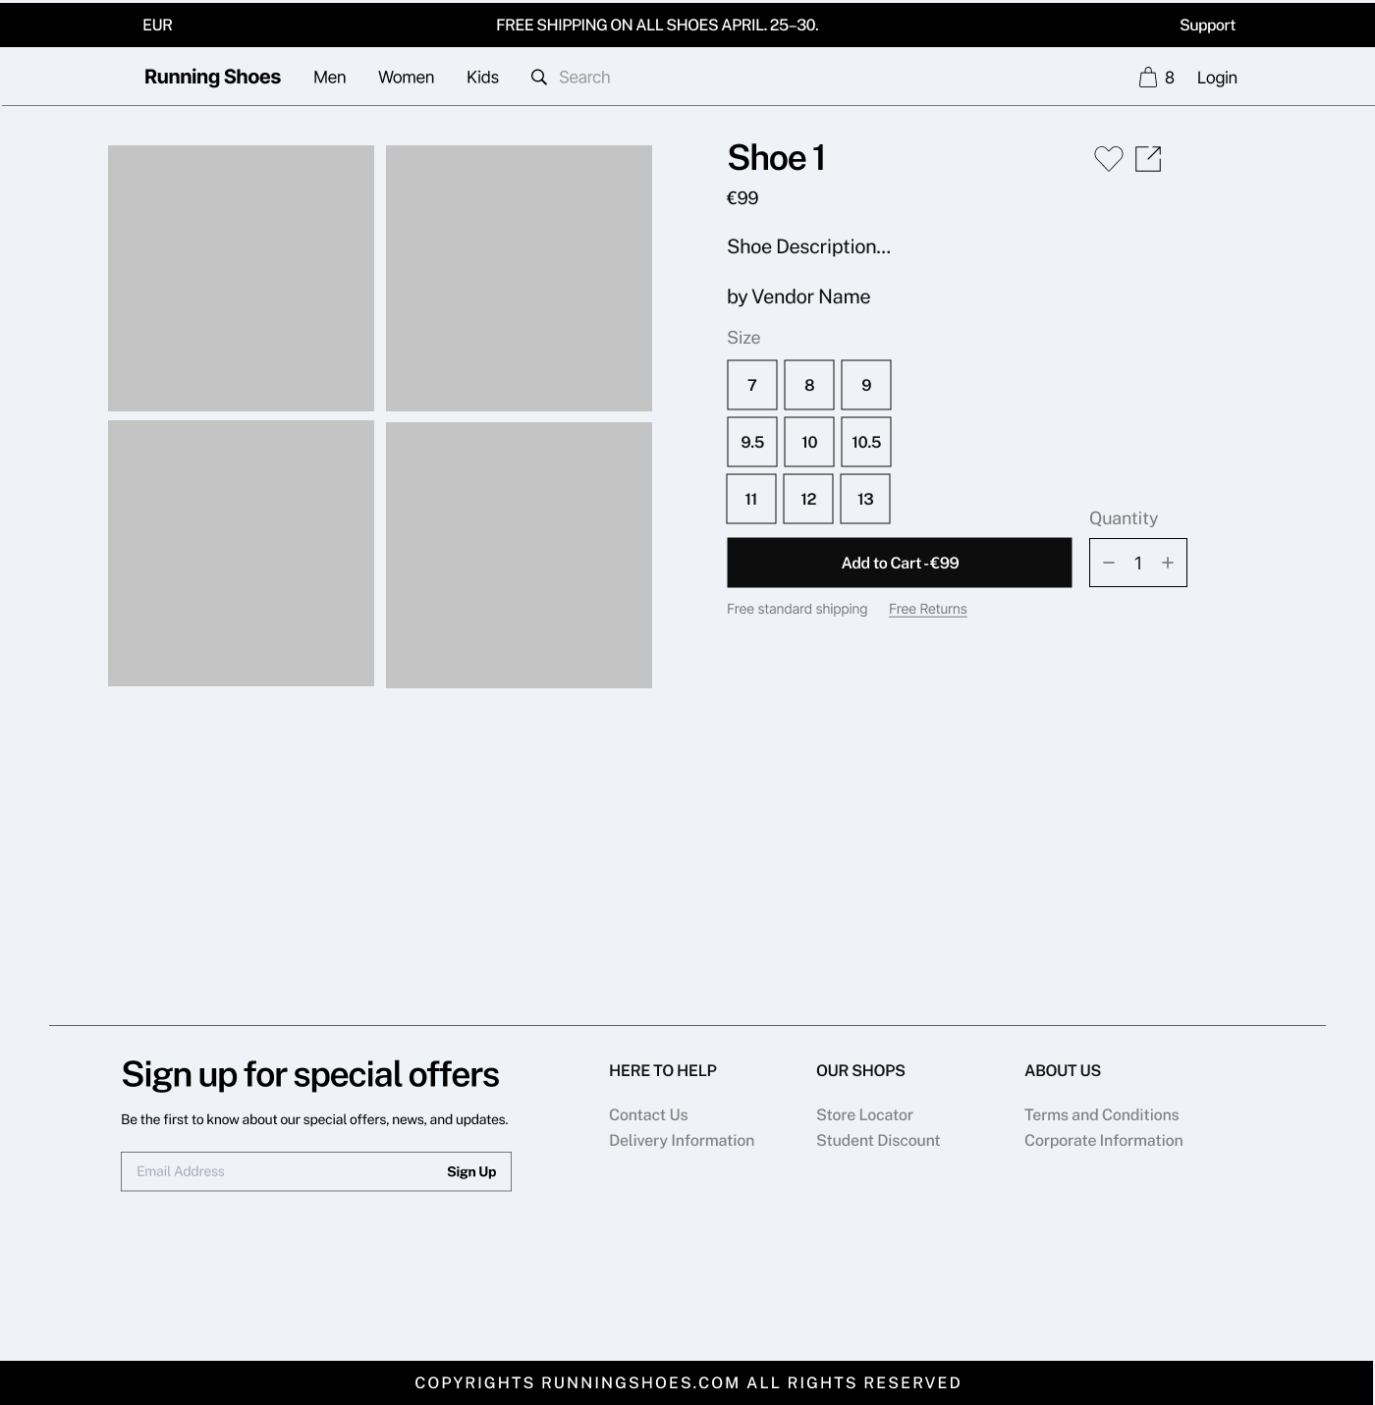

### **Wireframe 4: Cart Page**

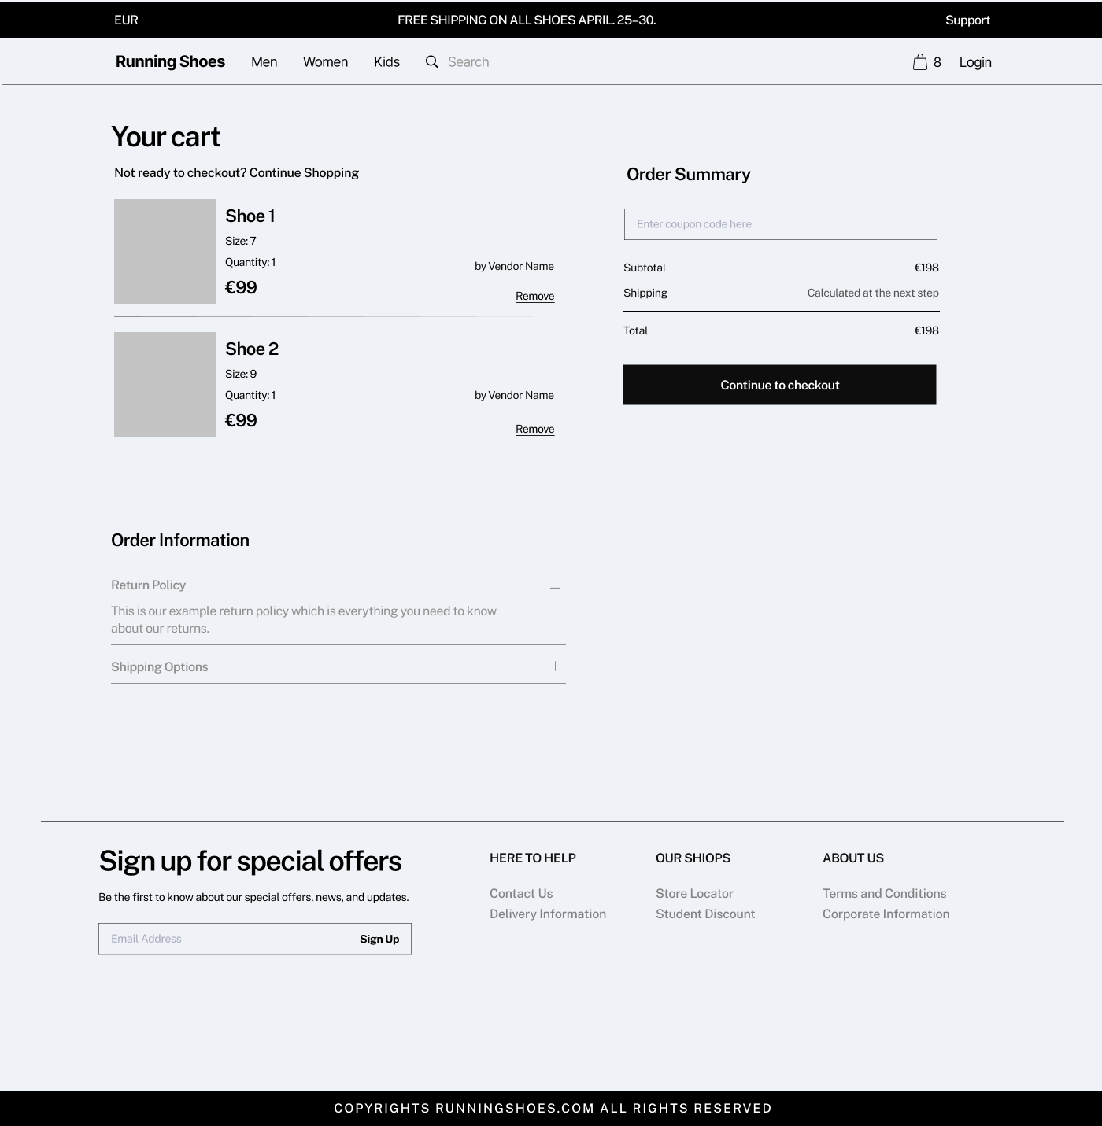

### **Wireframe 5: Checkout Page**

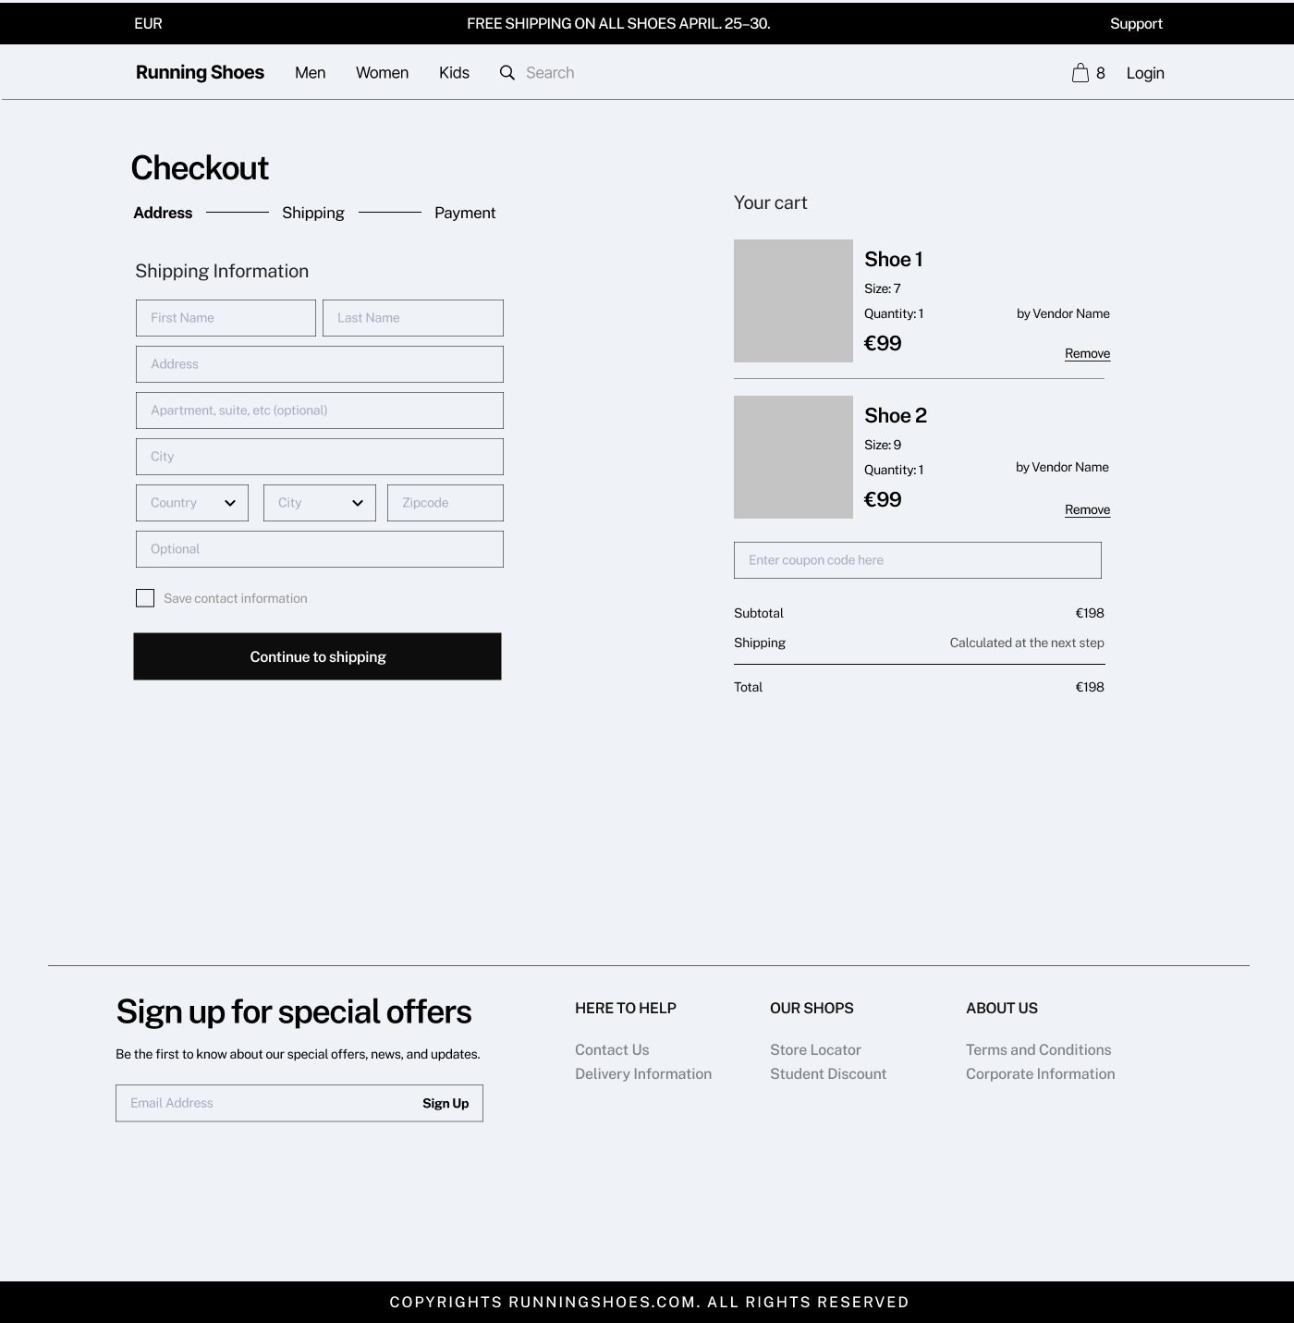

## **2.7. Considered the UI Principles**

In designing the user interface (UI) for the running shoe website, careful consideration was given to fundamental UI principles aimed at enhancing usability, clarity, and overall user satisfaction. By sticking to these principles, the goal was to create an intuitive and visually appealing interface that not only guides users easily through their shopping journey.

One of the primary UI principles used in the design is visual hierarchy. This principle ensures that elements on the website are organized in a way that guides users' attention effectively, prioritizing important information and actions.

Consistency is another key UI principle that was carefully implemented throughout the website. Consistent design elements, such as color schemes, typography, and navigation menus, create a consistent and familiar user experience across different pages and sections of the website. This consistency not only enhances usability by reducing cognitive load but also reinforces the brand identity, fostering trust and recognition among users.

Clarity is important in ensuring that users can easily understand and interact with the website. Through clear and concise labeling, descriptive product images, and intuitive navigation cues, users are guided through their shopping journey with minimal confusion or frustration. Additionally, the use of whitespace and proper alignment helps to declutter the interface, allowing important elements to stand out and reducing visual clutter.

Accessibility is another crucial consideration in UI design, ensuring that the website is usable and inclusive for all users, regardless of their abilities or devices. By incorporating accessible design elements such as alternative text for images, keyboard navigation support, and color contrast ratios that meet accessibility standards, the website aims to accommodate users with diverse needs and preferences, enhancing their overall experience and ensuring inclusivity.

Also, the UI design reflects the brand identity and values of the running shoe website, showing a sense of professionalism, reliability, and athleticism. Branding elements such as logo placement, color schemes, and imagery are strategically integrated into the design, creating a determined and memorable brand experience for users.

In summary, by considering principles of visual hierarchy, consistency, clarity, accessibility, and brand identity, the UI design of the running shoe website aims to create a seamless and enjoyable shopping experience that meets the needs and expectations of its target audience while reinforcing the brand's identity and values.

# **3. User Experience Evaluation**

## **3.1. Implemented UI Design**

The UI design was easily converted into a working prototype using HTML, CSS, and JavaScript. The prototype brings the desired UI to life through careful coding and attention to detail, allowing visitors to interact with the website and test its functionality in a simulated environment.

### **Page 1: Home Page**

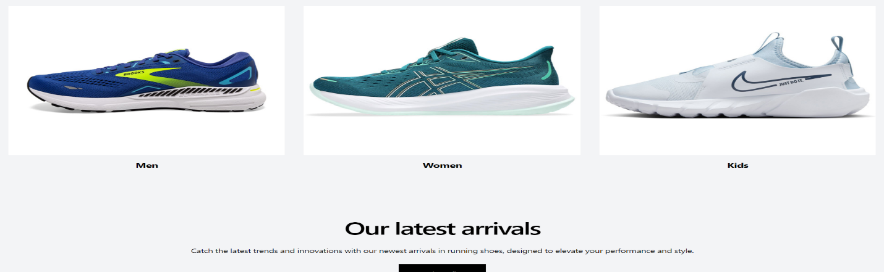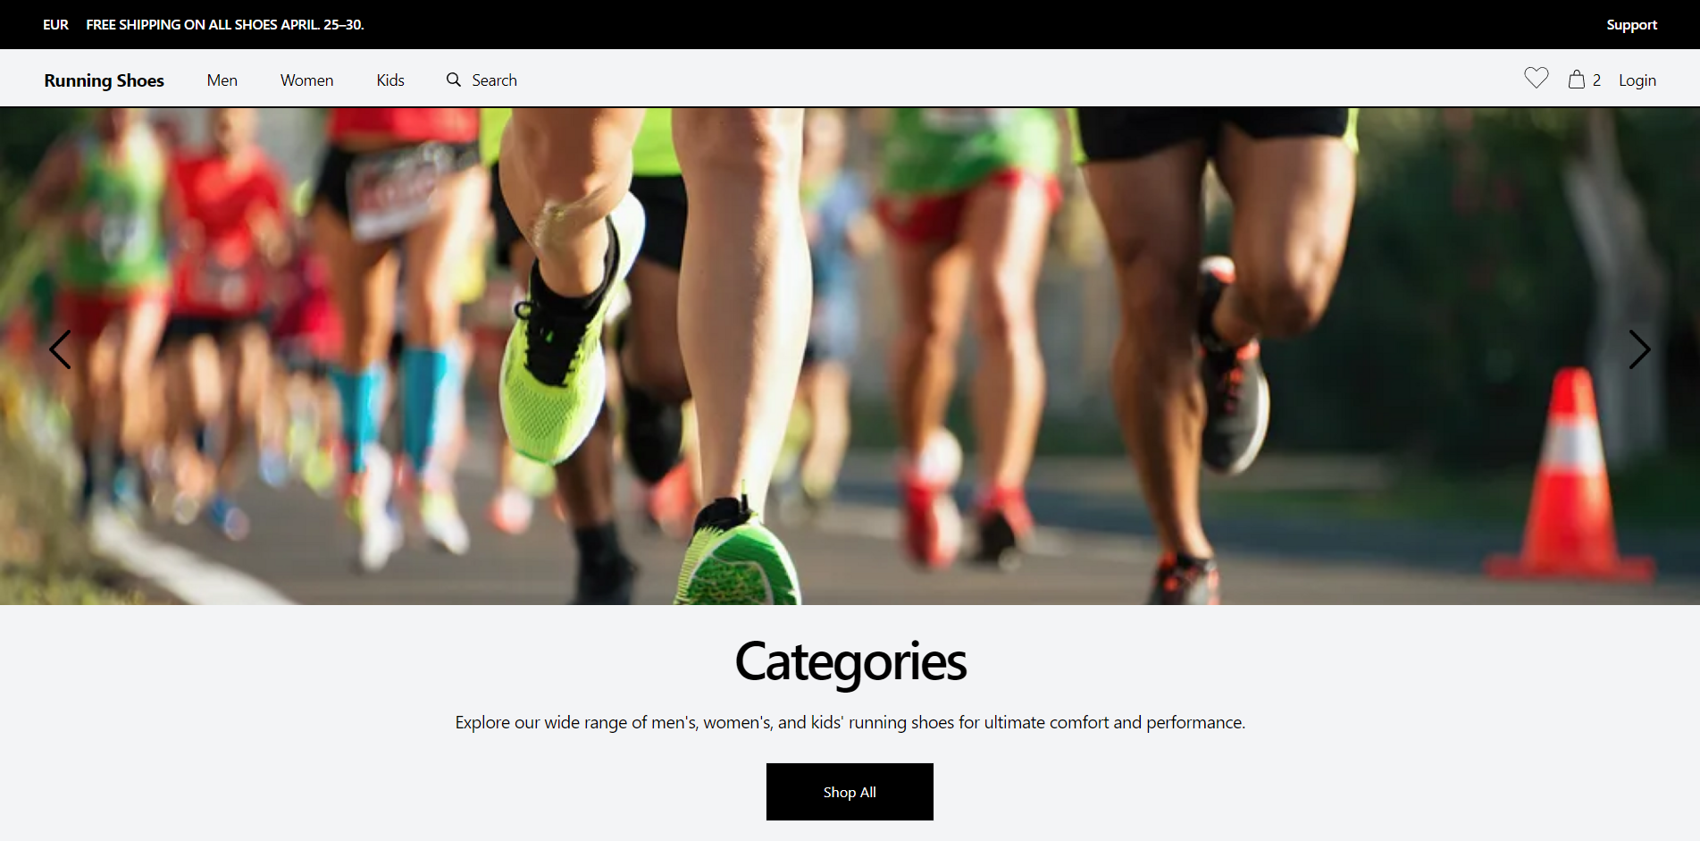

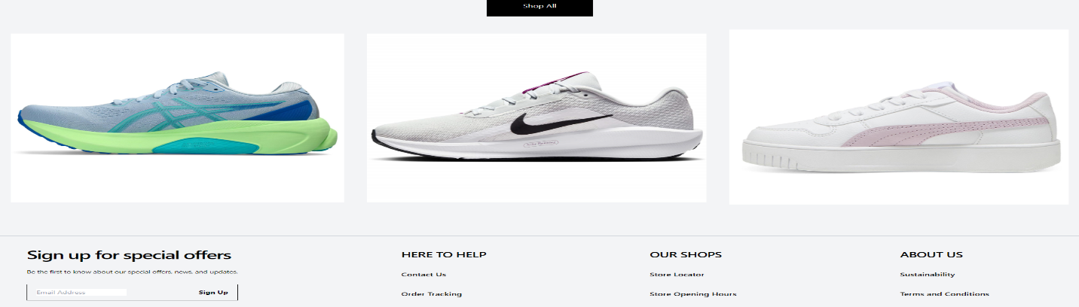



### **Page 2: Shop Page**

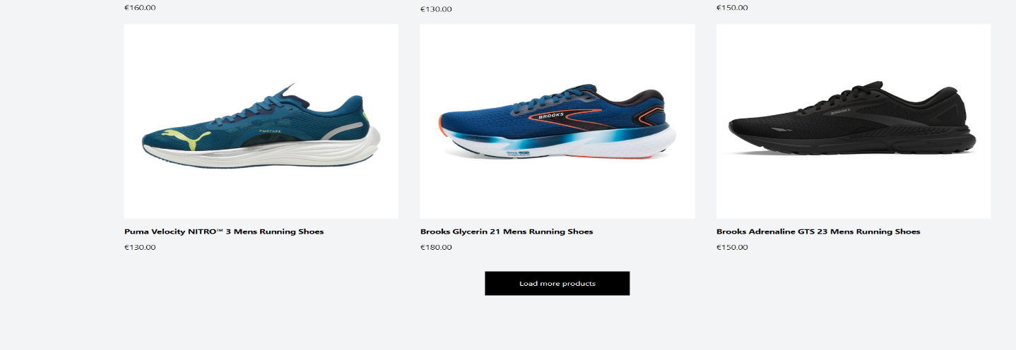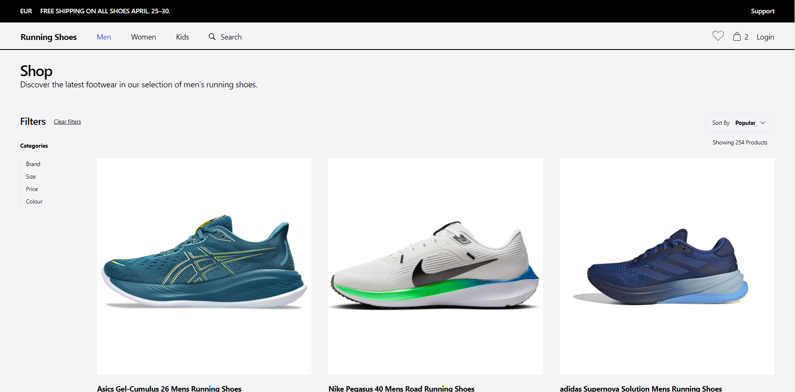



### **Page 3: Product Page**

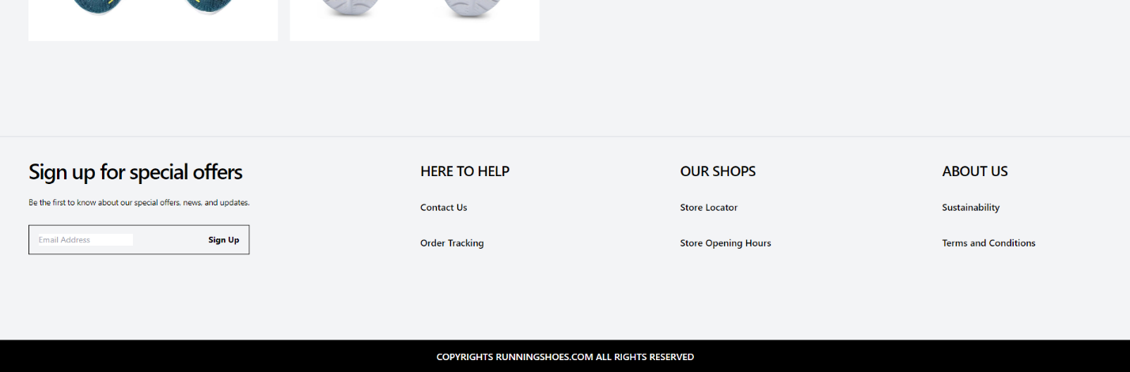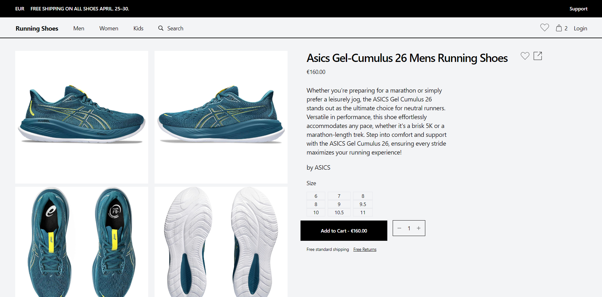

### **Page 4: Cart Page**

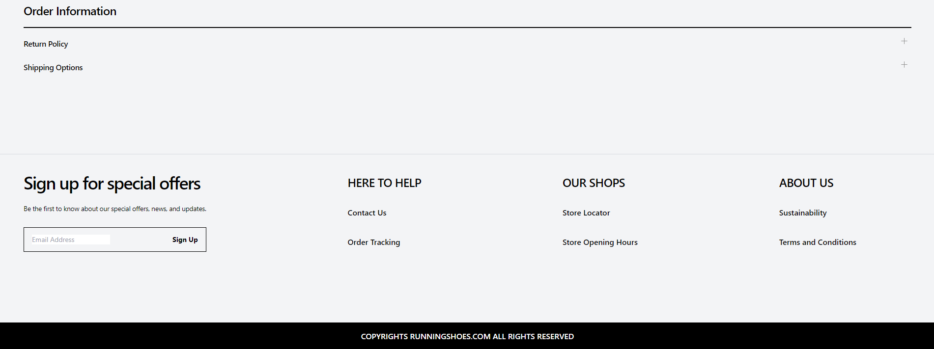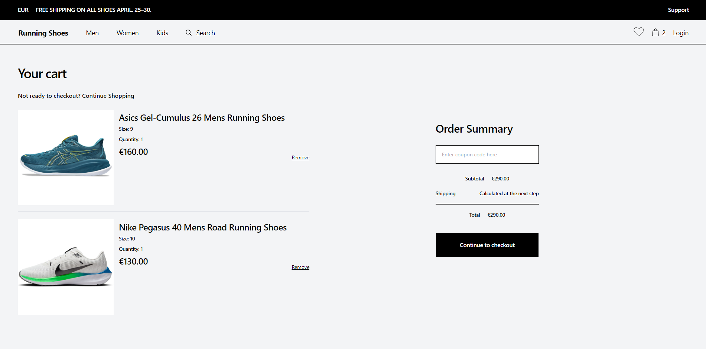

### **Page 5: Checkout Page**

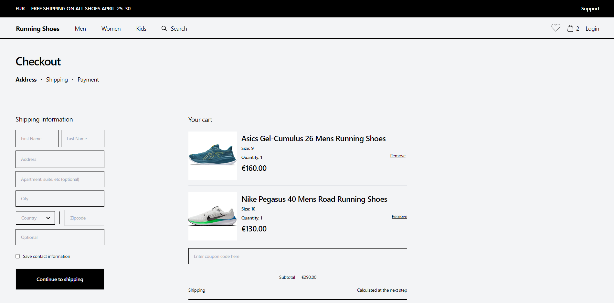

## **3.2. Conducted Usability Testing**

Usability testing played an important role in evaluating the effectiveness of the user interface (UI) design and identifying areas for improvement to enhance the overall user experience. This phase involved engaging with real users and observing their interactions with the website prototype to gather valuable feedback on navigation, task completion, and overall satisfaction.

The usability testing process happened by asking a diverse group of participants (Fellow students, friends, and family) who closely resemble the target audience demographic. This ensured that the feedback obtained would be representative of the actual users who would be interacting with the website. Participants were selected based on criteria such as age, gender, level of tech literacy, and familiarity with online shopping.

Each participant was given specific tasks to perform on the website prototype, simulating real-world scenarios that users might encounter during their shopping journey. By observing participants' interactions and recording their actions, insights were gained into how users navigated the website and encountered any usability issues or challenges.

During the testing sessions, participants were encouraged to think aloud and provide verbal feedback as they completed each task. This allowed me to gain deeper insights into participants' thought processes, preferences, and frustrations in real-time. Additionally, participants were asked to rate their satisfaction level after completing each task.

Usability testing revealed several valuable insights into the user experience, highlighting areas of strength as well as areas in need of improvement.

**Strengths:**

**1. Clear Visual Hierarchy:** Participants liked the website for its clear visual hierarchy, which effectively guided their attention to important elements such as product categories, featured products, and call-to-action buttons. The use of bold typography and contrasting colors helped to distinguish different sections of the website, making it easy for users to navigate and find relevant information.

**2. Intuitive Navigation:** The website's navigation menu received positive feedback for its intuitive structure and ease of use. Participants were able to quickly locate and access different sections of the website, including product categories, search functionality and cart. The consistent placement of navigation elements across pages further enhanced usability and reduced cognitive load.

**3. Responsive Design:** Users appreciated the website's responsive design, which ensured a seamless browsing experience across various devices and screen sizes. Participants found that the layout and functionality remained consistent and easy to interact with, contributing to a positive user experience.

**Areas for Improvement:**

**1. Enhanced Product Information:** Participants highlighted the importance of detailed product information, including comprehensive descriptions, sizing charts, and customer reviews. Improving the depth and quality of product information would put confidence in users and facilitate informed purchase decisions. Additionally, incorporating user-generated content such as ratings and reviews would provide valuable social proof and enhance trust in the brand and its products.

Following the completion of usability testing sessions, the feedback collected was analyzed to identify recurring themes and prioritize actionable insights for design refinement. This iterative process allowed for iterative improvements to the UI design, addressing usability issues and enhancing the overall user experience based on real user feedback.

In summary, usability testing served as a crucial step in the UI design process, providing valuable insights into users' interactions, preferences, and pain points. By incorporating user feedback and iteratively refining the design, the aim is to create a user-friendly and intuitive interface that meets the needs and expectations of the target audience effectively.

# **4. Conclusion**

In conclusion, the design and evaluation of a user interface for an e-commerce website selling running shoes is an adaptable process that requires careful consideration of user needs, preferences, and behaviors. By adhering to fundamental UI/UX design principles and methodologies, I have created a UI that prioritizes usability, clarity, and accessibility, aiming to deliver a seamless and enjoyable shopping experience for users.

Throughout the project, extensive research, iterative design iterations, usability testing, and feedback collection have been instrumental in refining the UI design and ensuring that it meets the needs and expectations of the target audience effectively. By incorporating user feedback and insights into the design process, I have been able to address usability issues, improve navigation pathways, and enhance overall user satisfaction.

Moving forward, continuous monitoring and optimization of the UI design will be essential to adapt to evolving user preferences and technological advancements. By remaining agile and responsive to user feedback, I can ensure that the UI design remains user-centric and delivers a consistently high-quality experience for all users, ultimately driving engagement, loyalty, and success for the running shoe website.